**Project 9:How to automatically trigger the job in Jenkins using pipeline script integrating with the github**

* **Manage Jenkins**

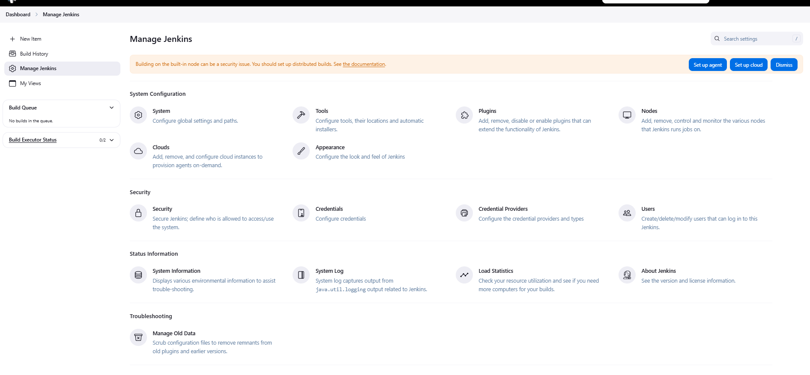

* **Installing plugins :pipeline stage view**

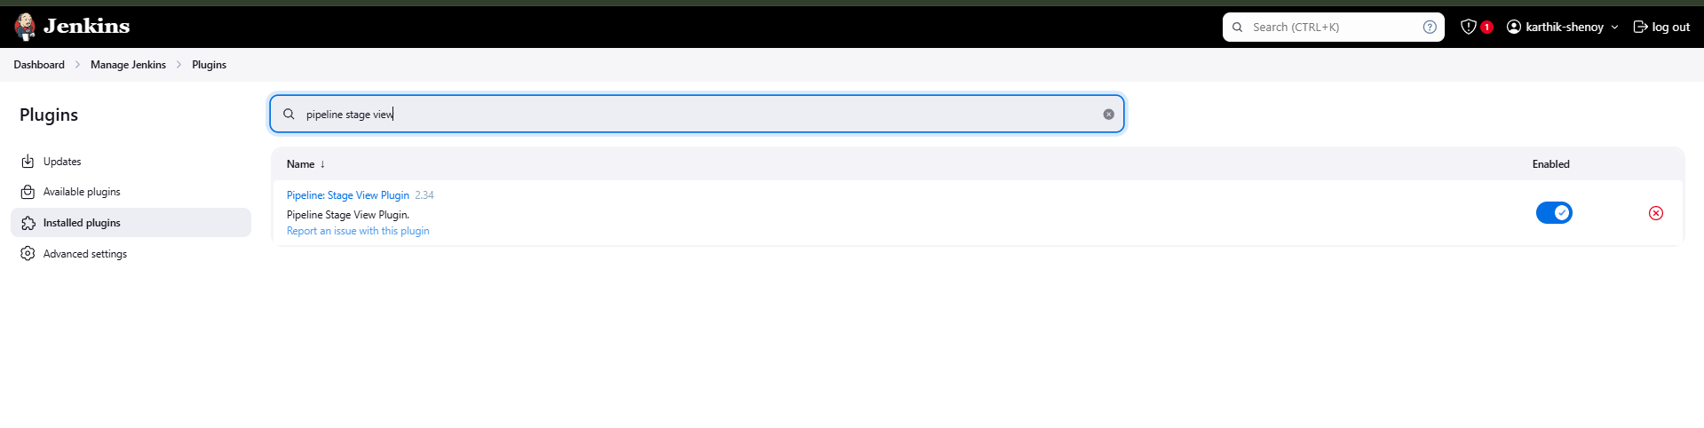

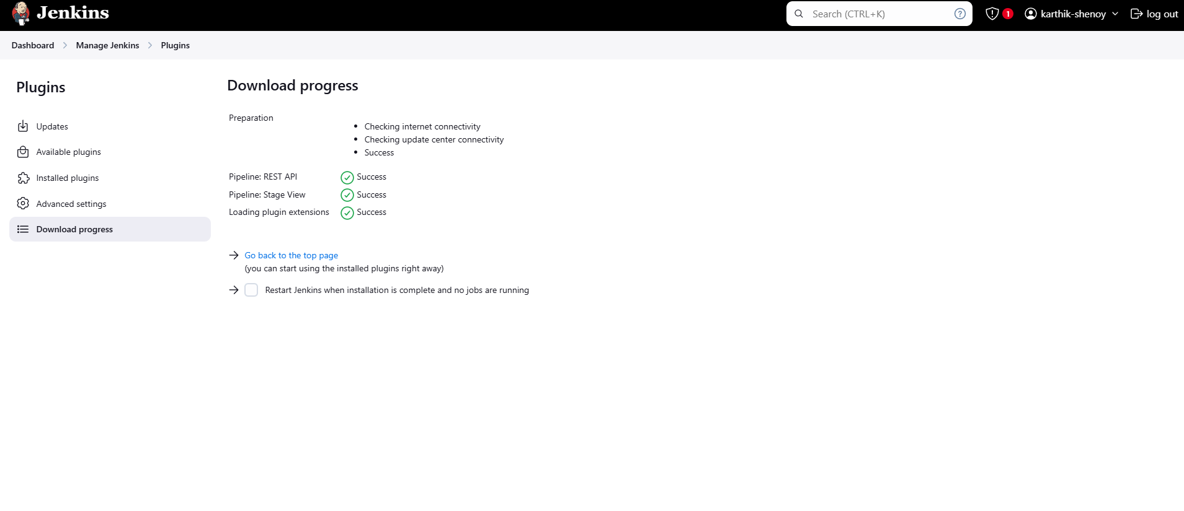

* **Adding a Jenkinsfile under Jenkins1 directory**

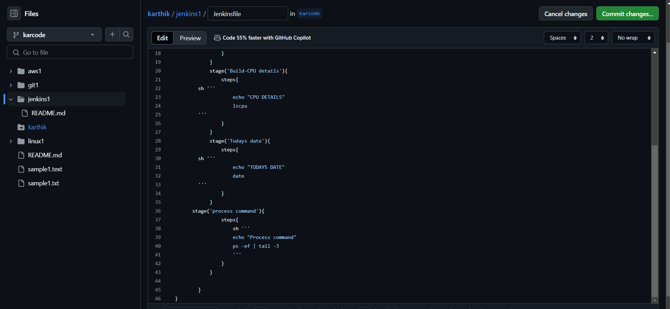

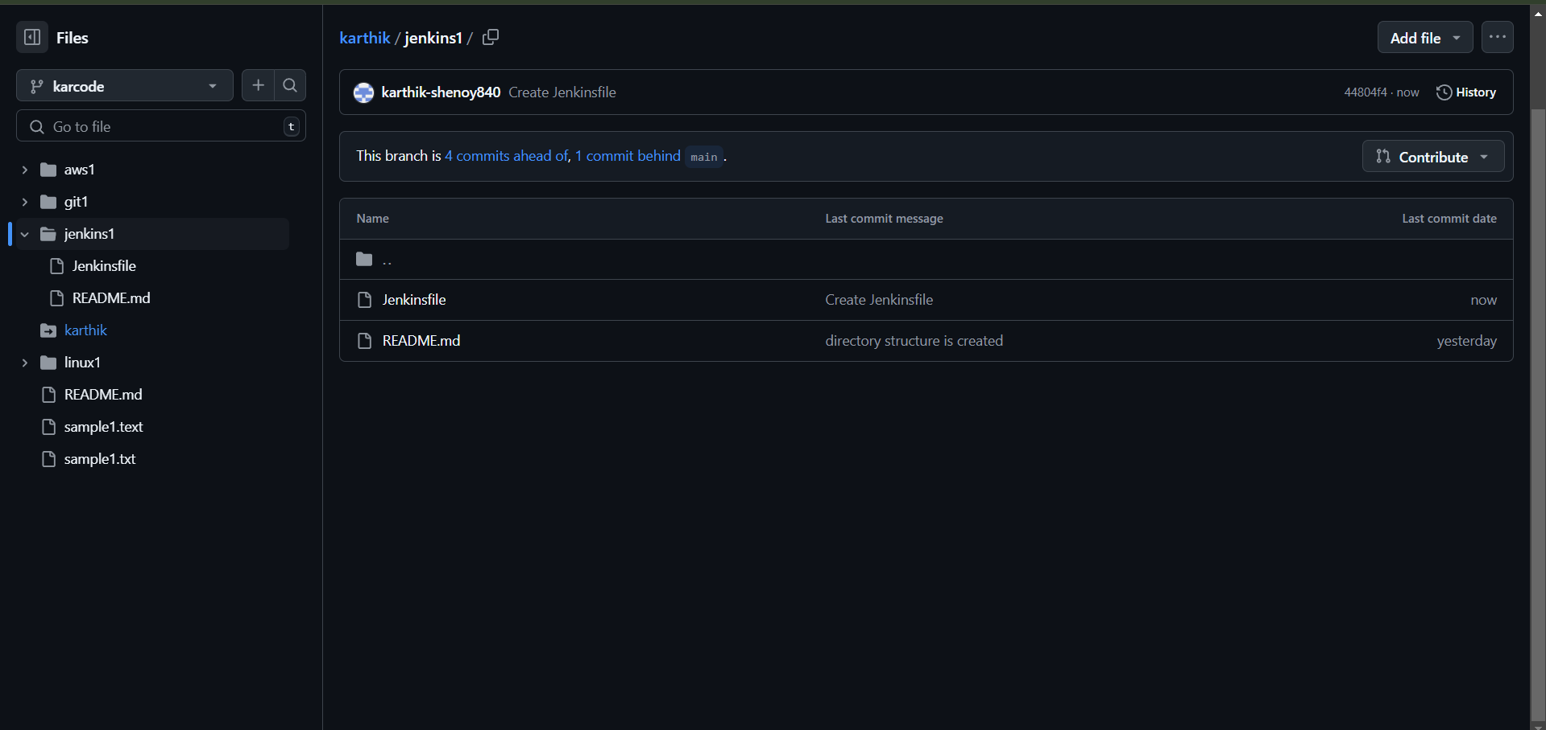



* **Creating a webhook**

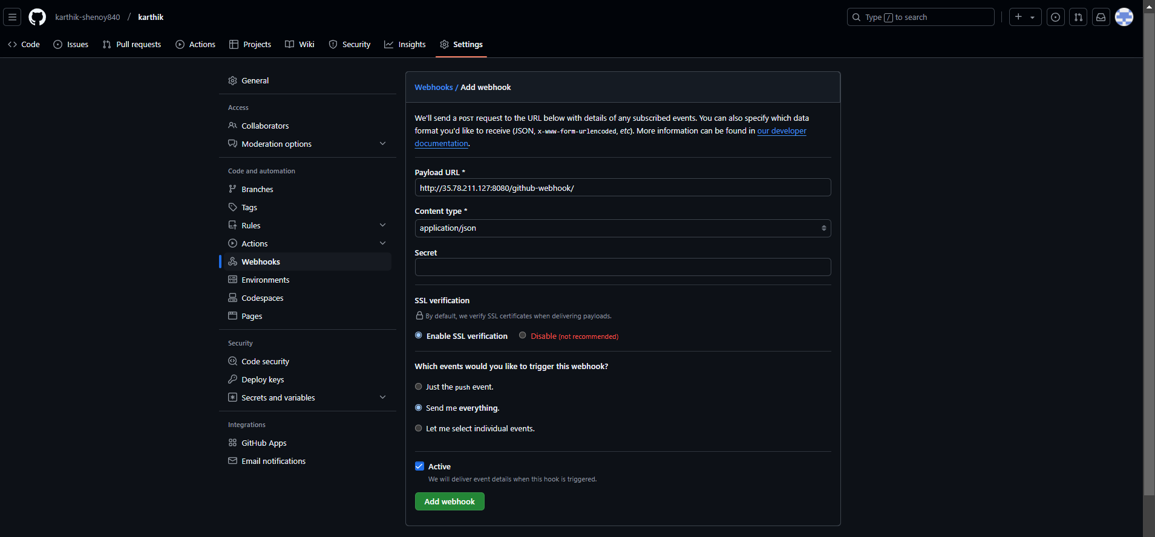

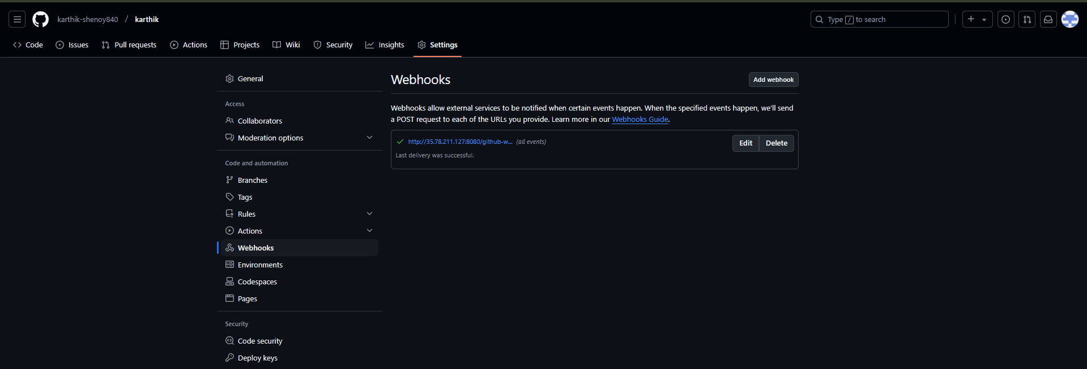

* **New job created as Job-pipeline karthik**

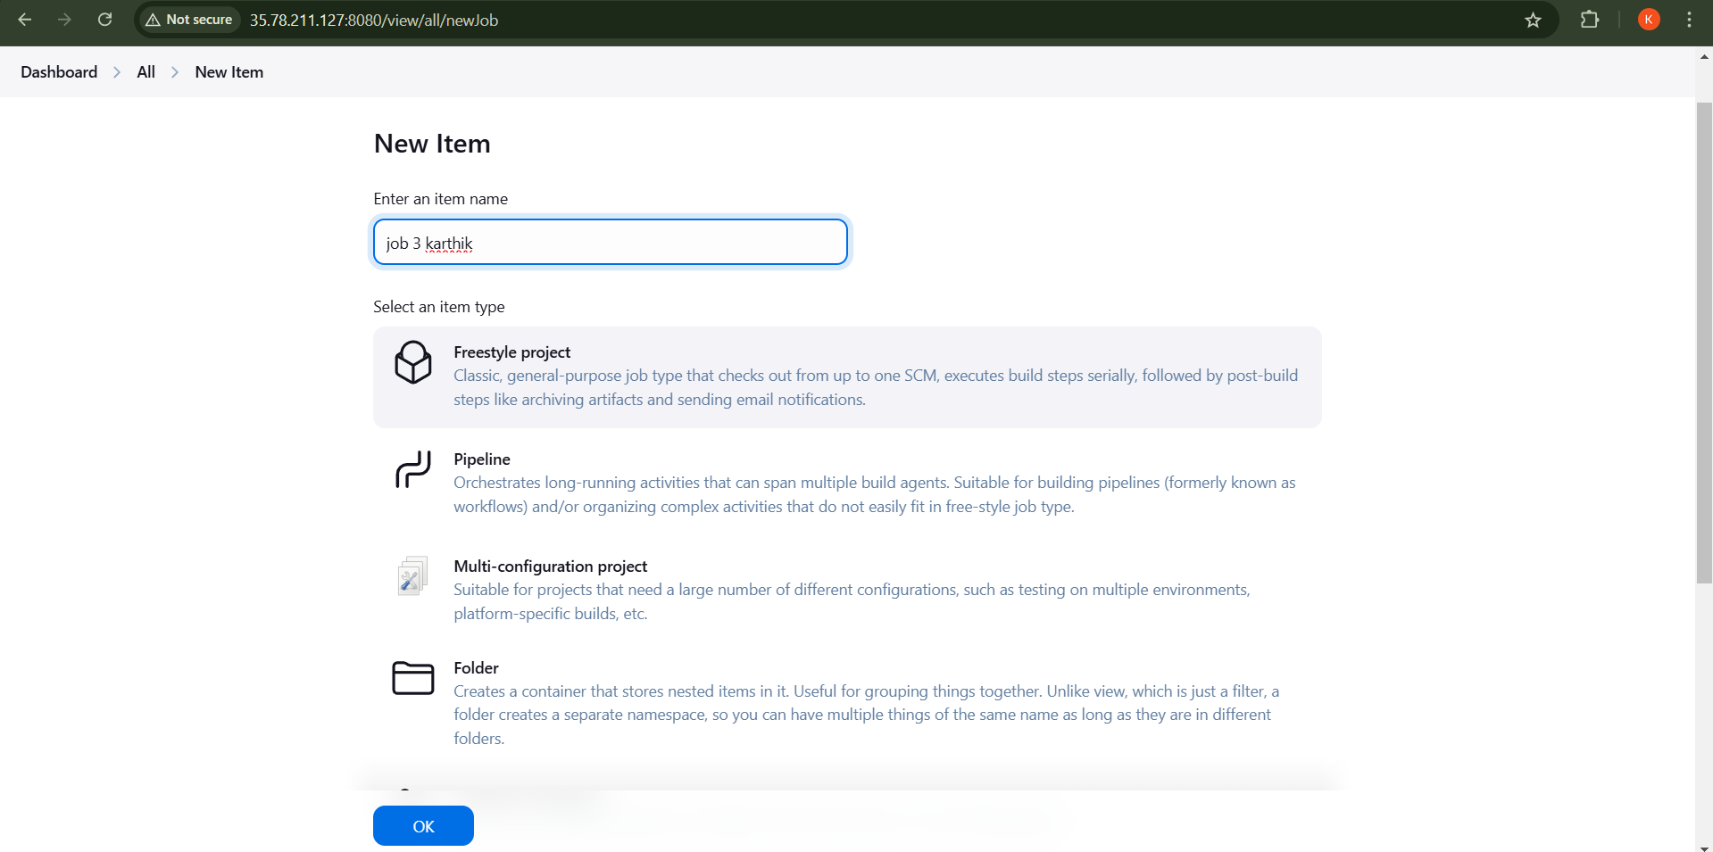

* **Configuration**

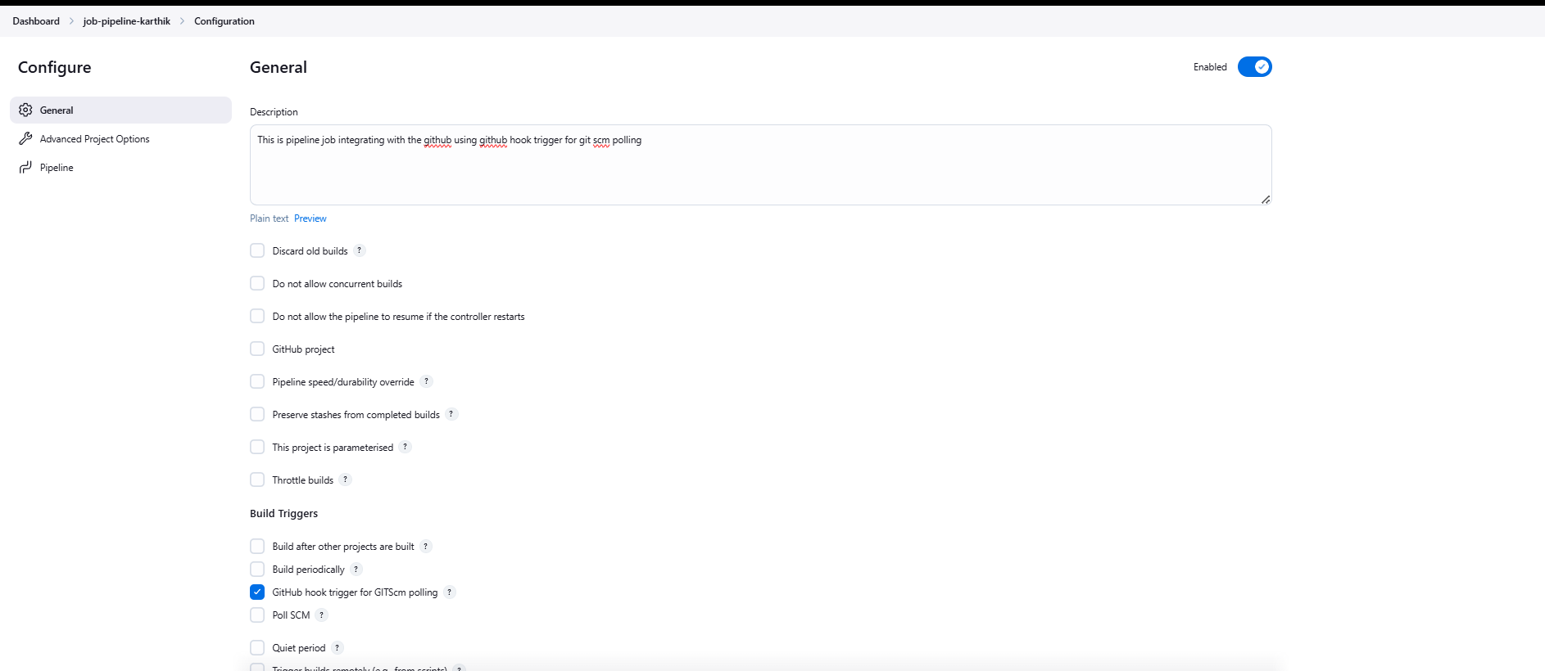

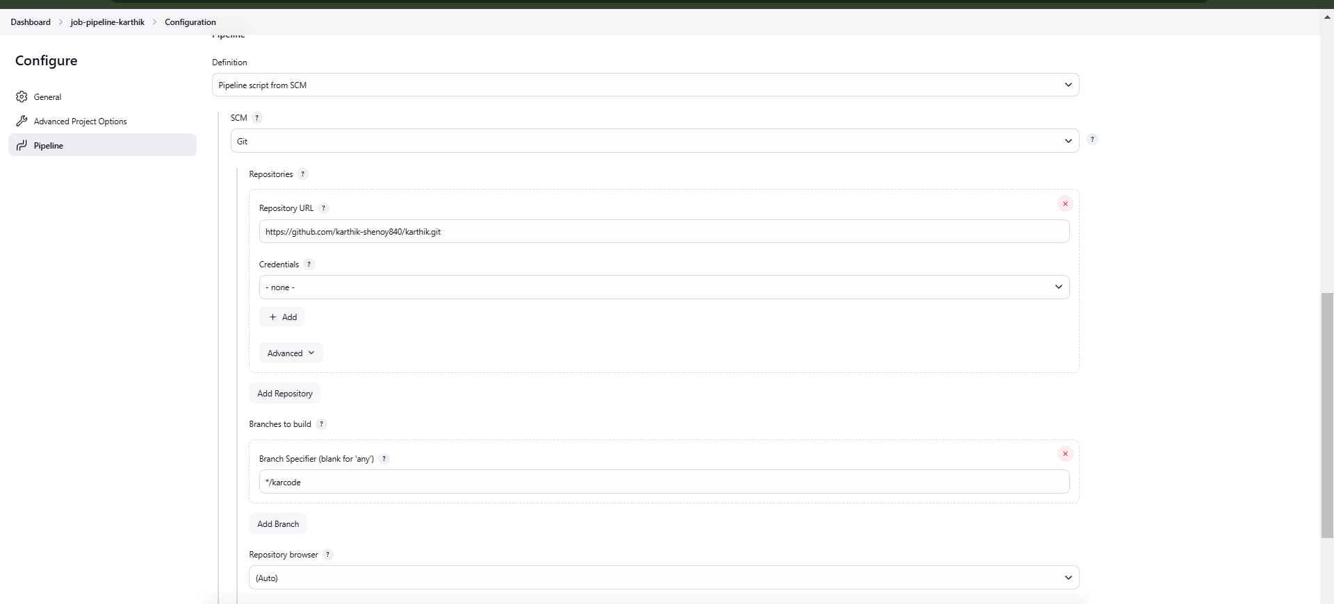

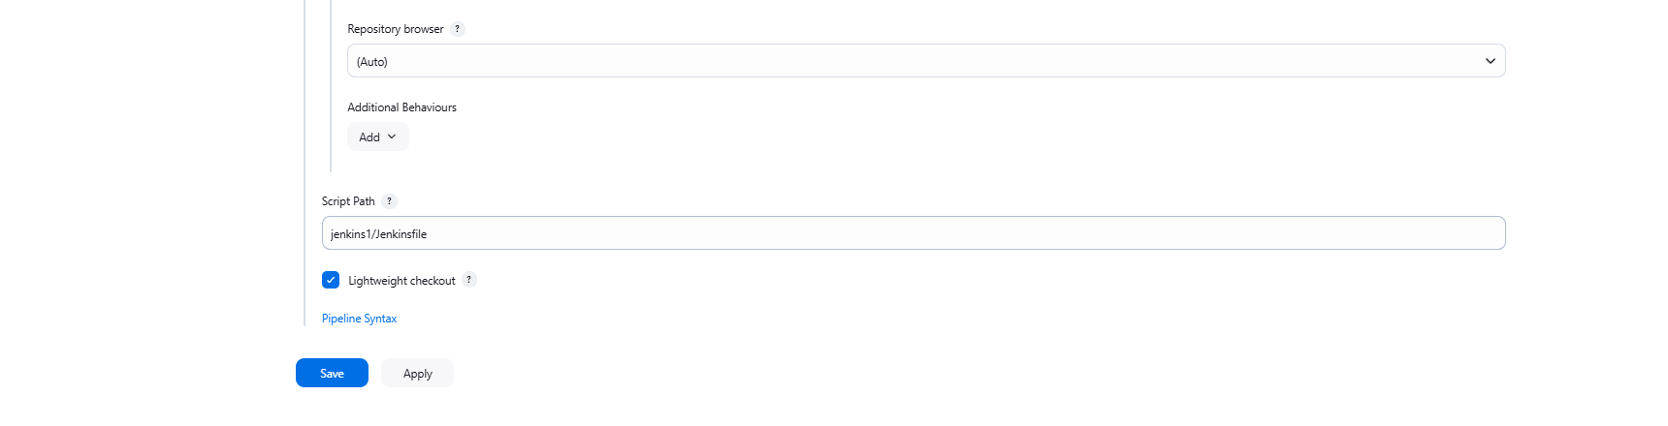

* **Final output**

